**This will be a guide on how to set up the raspberry pi pulse sensor.**

**All wires are male to female unless stated otherwise**

*Step 1*: put the back left leg of the MCP3008 - 8 Channel 10-Bit ADC with SPI interface into E6 and the back right into the F6. The front two go into the E and F 13

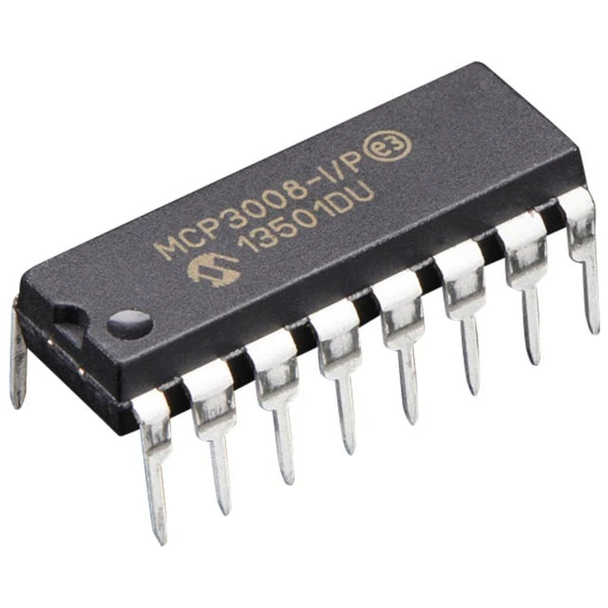

back

front

*Step 2*: place a wire in A7 and and the other end 12 down on the right side of the pi

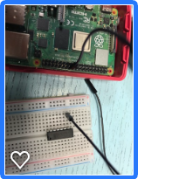

*Step 3*: place a wire from A8 to 10 down on the left

*Step 4*: place a wire from A9 to 11down in the left 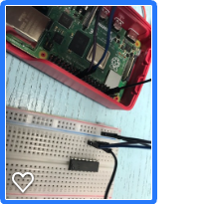

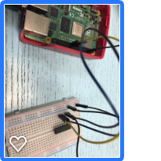

*Step 5*: place a wire from A10 to 12 down on the left

*Step 6*: place a wire A6 to negative 5

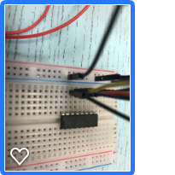

*Step 7:* place a wire from A11 to negative 11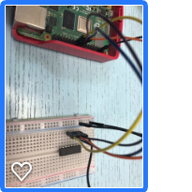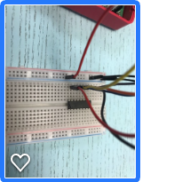

*Step 8*: place a wire from A12 to positive 13

*Step 9*: place a wire from A13 to positive 14

*Step 10*: put the negative wire of your sencor into g 13

*Step 11*: put the ground wire of the sensor into negative 2

*Step 12*: put the positive wire of the sensor into the first part on the left of the pi

